Math 10

Lesson 3–3 Answers

**Lesson Questions**

**Question 1**

a) G, 18 years

b) A, newborn

c) B and C, 100 cm

d) D and E, 10 years

e) B

**Question 2**

a)



ascending

descending

resting

b) These results may be due to other things, but the most likely explanation is given.

c)Make the slope of the graph steeper.

d)See above.

**Question 3**

a) the temperature of a cup of hot chocolate over time **→ Graph C**

b) a car accelerating to a constant speed **→ Graph B**

c) the distance a person walks during a hike **→ Graph D**

d) the height of a soccer ball kicked across a field **→ Graph A**

**Question 4**

The car takes 2 h to travel 140 km to Kikino; the car stops for 1 h: the car takes approximately 45 min to travel 50 km toward Athabasca; the car stops for approximately 45 min; the car takes 1 h to travel approximately 90 km to Athabasca

**Question 5**

If the food supply is limited, the bacteria eventually will run out of food and die off.

Graph A can be ruled out since it indicates continued growth.

Graph B is also not the correct choice. It shows the number of bacteria decreasing at the start while the food supply is high, reaching a low point, and then increasing.

Graph C is the correct choice. The increase in bacteria is initially slow but then goes through a period of rapid growth. The number remains stable for a while. Then the bacteria die off because there is no more food.

**Question 6**

Graph B. It shows a person growing to their maximum height, remaining there for a long time and then gradually becoming shorter in older age.

**Question 7**



Alicia accelerates from 0 to 8 m/s.

Alicia slows down from 8 m/s to 0.

Alicia maintains a constant speed of 8 m/s.

**Question 8**



**Assignment**

1.

■ a horizontal line segment means that the speed is constant

■ a segment that goes up to the right means that the speed is increasing over time

■ a segment that goes down to the right means that the speed is decreasing over time

2.

a) Bear F; approximately 650 kg

b) Bear A; approximately 0.7 m

c) Bears D and E; 400 kg

d) Bears D and H; approximately 2.25 m

3.

a) 8 m; 06:00 and 18:00

b) 2 m; 00:00 (midnight), 12:00 (noon), and 24:00 (midnight)

c) Approximately 6.5 m

d) At approximately 02:20, 09:40, 14:20, and 21:40

4. Graph B

5.

a) 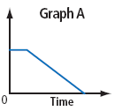

i) Graph A – The train travels at a constant speed before slowing down at a constant rate. shows a short horizontal distance, which represents a constant rate, then a steady decline, which represents a constant decreasing rate.

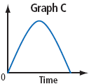

ii) Graph C – This curve would represent the changing height of a thrown football as it rises in the air and then falls back to the ground.

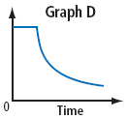iii) Until the popcorn maker heats up, no kernels will pop. The number of un-popped kernels remains constant as shown by the horizontal section in graph D. When the correct temperature is reached, the kernels start popping, but not at a constant rate. The smooth decreasing curve in graph D shows the number of un-popped kernels decreasing.

b)

Example: Graph B shows a constant steep increase. This could represent the number of people in a building as the building fills up for a concert, assuming they enter at a constant rate. The graph shows no change for a time, as represented by the horizontal line. This represents the time when the concert is in session. The constant steep decline shows the people leaving the building at a constant rate after the concert.

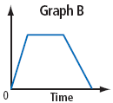

6. O to A – fast constant speed away from home

A to B – Gill is at rest

B to C – slower constant speed away from home

C to D – original fast speed toward home

7. O to A – descent from the surface to 15 m depth at a constant rate for 4 min

A to B – diver remains at 15 m for 6 min

B to C – diver descends another 10 m at a constant rate for 4 min

C to D – diver remains at 25 m for 4 min

B to C – diver ascends 25 m at a constant rate for 10 min

8.

a) A to B – the engine consumes 10 L of fuel over 2 h

B to C – 15 L of fuel is added to the tank over a short time

C to D – the engine consumes 10 L of fuel over 2 h

D to E – the engine was turned off for 2 h

E to F – the engine consumes 15 L of fuel over 3 h

F to G – 25 L of fuel is added to the tank over a short time

b) 25 L; no

9.

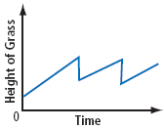a) The graph’s horizontal axis is labelled as Time and the vertical axis is labelled as Height of Grass. The graph shows a constant increase, which represents the grass growing over time. Then, a vertical segment represents the grass being cut. This pattern continues.

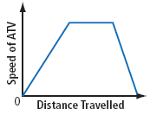 b) The graph’s horizontal axis is labelled as Distance Travelled, and the vertical axis is labelled as Speed of ATV. The graph shows a constant increase, which represents the distance travelled as the ATV accelerates. The horizontal line represents a constant speed. The constant decrease represents the ATV slowing down to a stop.

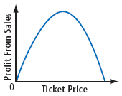c) The graph’s horizontal axis is labelled as Ticket Price and the vertical axis is labelled as Profit From Sales. The graph show that as the ticket price increases, profits from sales increase until a maximum profit is reached. After that maximum profit is reached, as ticket prices increase, profit decreases.



10.

Graph should dip down, not up.

Indicates a fast change in volume rather than a gradual increase.

Indicates a gradual change in volume rather than an instantaneous mute.

11. There are three errors:



12. Answers may vary. For example:

a) A person walks from home to a park 1.5 km away in 10 min. He sits on a park bench and reads for 10 min. Then he walks home.

b) A person sprints down a street starting from a standstill. It takes the person 5 s to reach a speed of 7.5 m/s. After 5 s of running at 7.5 m/s, the person slows down and stops in 5 s.

13.

14. 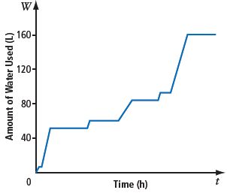Let the horizontal axis represent time, in hours, and the vertical axis represent amount of water used, in litres. The first increase represents flushing the toilet and washing my hands. The next sharp increase represents taking a shower. The horizontal section represents no water use for a time. Then, the short rise represents flushing the toilet and washing my hands. The next rise represents running the dishwasher. Another horizontal section represents no water use for a time. Another short rise represents flushing the toilet and washing my hands, followed by a sharp rise that represents running a bath. Finally, a horizontal section represents no water use for a time.

15. 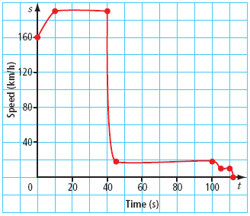Let the horizontal axis represent time, in seconds, and the vertical axis represent speed, in kilometres per hour. The skydiver jumps from a plane that is travelling at a speed of 160 km/h. So, the graph starts at this speed. The skydiver accelerates for 10 s to a speed of 190 km/h. This is represented on the graph as a sharp constant increase. Adopting the standard flat and stable position, the skydiver stays at this speed for 30 s. On the graph, this is represented as a horizontal line segment. The skydiver opens his parachute, which quickly slows his descent to 18 km/h. This is represented on the graph as a sharp decrease that is almost a vertical line. He maintains this speed, which is represented on the graph as a horizontal line. He slows down and lands. A short decrease on the graph before the graph goes to zero indicates this final part of his descent.

16.

a) The graph indicates that time has moved backward. This means that as distance changed, time was taken away, which is impossible.

b) The vertical axis represents total distance travelled. The graph indicates that some of this distance is being taken away, which is impossible.